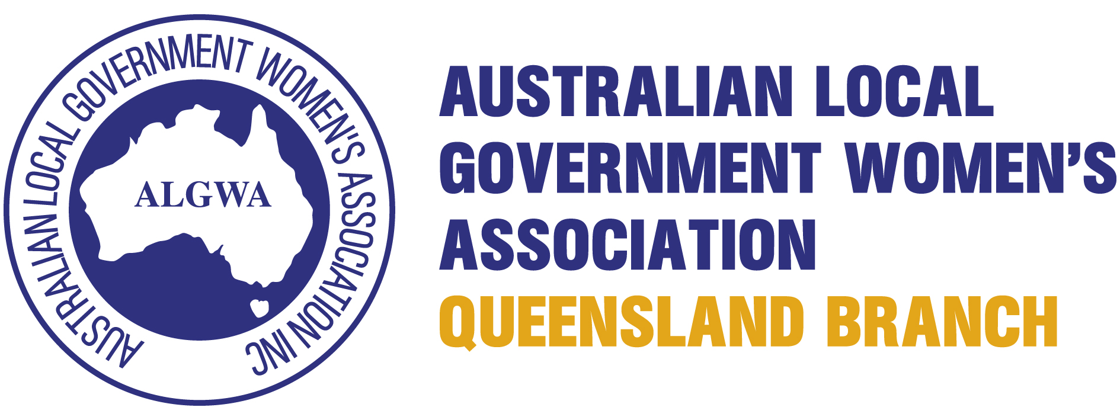
THE JULIE MICHAEL
Annual Member's Bursary Award
Cover Sheet
Personal Particulars

Title |  |  | Surname |  |  | First Name
Postal Address
Contact Details |  |  | Work |  |  | Home
 |  |  | Email

Applicant’s Declaration

- I declare that I am a current financial member of ALGWA Qld Branch, and will remain a financial member for the duration of study for which this bursary is applicable to.
- I declare that, to the best of my knowledge and belief, all the information provided in support of my application is true and correct.
- I have provided the original and one copy of my application.
- I have provided proof of my enrolment / intended course of study.
- I have provided a copy of my current CV.
- I agree to undertake the professional development initiative stated in this application in the given timeframe and to a satisfactory level of performance as determined by the Management Committee.
- I agree to assist in the promotion of The Julie Michael ALGWA Member's Bursary in subsequent years (if required) and agree that details of my application may be used for future promotional purposes.
- I understand that funds provided by this Member’s Bursary shall be spent by 30 June and that I am required to meet the balance of the cost of study.
- I understand that as the recipient, I am responsible for ensuring any components required under this Member's Bursary are provided as required.
- I agree that if I fail to comply with any of the above conditions pertaining to this Member’s Bursary, it may be cancelled and all outstanding monies will be debited in full to the undersigned.
- I agree to provide a written report to the Management Committee within three (3) months of completing the professional development initiative identified in this application.
Attached original application and a copy | Yes | No
Attached current CV | Yes | No
Attached proof of membership | Yes | No

Applicant’s signature |  | Date

Acknowledgement

Please complete this portion as it will be returned as acknowledgement of receipt of your application to the Australian Local Government Women’s Association Queensland Branch Annual Member's Bursary Award.

Please print your name and address in this space: | Date application received:  (to be completed by ALGWA Qld)

THE JULIE MICHAEL
Annual Member's Bursary Award
Explanatory Notes

Julie Michaels commenced in the role of Planning Officer with Southern Downs Regional Council in 2007 having just completed a Master of Urban and Regional Planning at the University of Queensland. Julie's previous experience in the legal professional and as a Councillor were of great assistance in her new role in town planning and development assessment. Julie joined ALGWA and was the Zone 3 representative and later became Vice President. She was a valuable member of the ALGWA Committee and assisted ALGWA with valuable advice throughout her tenure as a member. Julie was popular with staff and customers alike and remained with Southern Downs Regional Council until her health failed.
The Queensland Branch of the Association has established an Annual Member's Bursary to encourage and assist all Local Government employees, both male and female, to further their education. One Member's Bursary will be awarded annually.
Members of ALGWA Queensland Branch who have demonstrated their commitment to undertake further studies directly related to the applicant's field of employment are eligible to apply for the Member's Bursary.
These studies may include a Diploma of Local Government Administration, Diploma of Planning or Diploma of Business (Frontline Management) conducted by Training Services, Local Government Association of Queensland, or other higher qualifications.
Proof of enrolment / details of intended course of study are required as part of your application.
Applicants must demonstrate an ability to make a positive contribution to their area of employment and their employer by further tertiary study.
The Member's Bursary may be awarded once only to any individual and there is no restriction on the number of eligible applications that may be made.
Applications shall be typed on the prescribed application form, together with relevant supporting documentation. The applicant’s employer and/or relevant professional body must endorse applications. No faxed or late applications will be accepted. Applications submitted via email are acceptable.
The Selection Panel may use a 1–10 scale to quantitatively rate each applicant against the selection criteria - 0 fails to satisfy criteria; 1-2 minimally satisfies criteria; 3 partially satisfies criteria; 4 marginally does not satisfy criteria; 5 satisfies criteria; 6 marginally exceeds criteria; 7 superior satisfaction of criteria; 8-9 excellent satisfaction of criteria; 10 exceeds criteria markedly.
The Member's Bursary shall comprise:
- A cash amount of $1,500.00 payable on presentation of a tax invoice. The Training Institution must invoice ALGWA Qld for this amount with the balance of the cost of study invoiced to recipient / business / council responsible for the balance of payment.
- A Certificate or other appropriate award will be presented to the recipient or a proxy during the Annual Local Government Women’s Association Annual Conference.
Applications will close on Monday, 23 October 2017 and should be returned to:
Karen Murray, Secretary
Australian Local Government Women’s Association
Queensland Branch Inc
Private & Confidential
C/- PO Box 3226
Logan City DC Qld 4114
Email: admin@algwaqld.asn.au

Employment Details

Name of Employer:
Address:
Telephone:
Please detail your current position in Council/business, including the status of your employment (for example, part time/full time/fixed term/contract) including specific information.
What is your course / intended course of Study? (Please specify the level)
How will you be studying? Part Time Externally
With which Tertiary Institution are you enrolled / intend to enrol?

Assessment Details

Demonstrate your ability to make a positive contribution to your Council. Please provide examples of how you do this, not a list of your responsibilities - (Value - 10 Points)
Please provide information relating to the relevance and benefit of the course to your employment and more broadly, to Local Government. Use this section to provide as much relevant information as possible, including examples to support your application - (Value - 10 Points)
Please provide a Letter of Endorsement from the Manager/Director of your Department/Branch in support of your application. The senior staff member must comment on:
1) your application;
2) any major work achievements; and
3) must provide evidence of the contribution you will make, through your studies, to enhance your role in Council and to Local Government in general
(Value - 10 Points)

Name
Position
Signature |  | Date

Referees

Name
Position
Contact Details | Telephone | Email

Name
Position
Contact Details | Telephone | Email

